OCHR FactSheet

**THE**

Executive Leadership Development Program

Audience: DON Workforce

Issued: Jun 2018

Executive Leadership

**Background**

The Executive Leadership Development Program (ELDP) provides participants extensive exposure to the roles and mission of DoD. In addition, the program helps participants develop a greater understanding and appreciation of what war fighters refer to as being “at the tip of the spear."

**Eligibility requirements**

Those DON civilians at the grade level of GS-12 through 14; Active Duty Military O-3 and O-4 level. Individuals must have at least a Bachelor's degree and a high-potential employee with a history of superior performance.

​**Program attributes**

ELDP is a very physically and mentally demanding program and you will need to adjust to rapidly changing conditions and situations. Some of the physical activities that participants may engage in are as follows: running obstacle courses, rappelling, land navigation, 3-5 mile field hikes, Leader Reaction Course, Nuclear Biological Chemical Chamber, Aviation Survival training (swim qualification), Basic Underwater Demolition SEAL (BUDS training), daily physical fitness training, and a Bayonet Assault course.

**Length of program**

During the course of the ten months of training, participants will travel to a variety of locations both in the United States and overseas, to train with the warfighter. Through intense, hands-on field experience, participants will be exposed to the many challenges that our Components face in carrying out the mission of the Department.

**How to apply**

Applicants must complete the following: ELDP Nominee Information Sheet, Resume, Statement of Interest, Qualification Statement (describe how you meet each of the following competencies: team building, accountability, decisiveness and influencing/negotiating (two-pages), ELDP Supervisor Assessment (250 words or less), and a Biography.

This Fact Sheet:

* Provides helpful information and tips on how to apply for this program
* Answers frequently asked questions

**NOTE:** Applicants are advised to check with their Command Training Representative for information regarding internal deadline dates and any additional requirements. Command endorsed packages must be submitted via the Portal Electronic Submission Process.

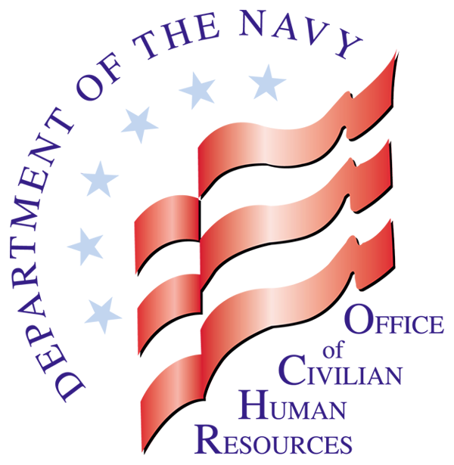

**OCHR**

**FactSheet**

Department of the Navy

Civilian Careers

Where Purpose and Patriotism Unite

**FactSheet: Executive Leadership Development Program** ***Issued: Jun 2018***

Frequently Asked Questions

Q. What leadership competencies does this program address?

A. Lead People, Team Building, Conflict Management, External Awareness and Critical Thinking

Q. What is the cost of this training?

A. The tuition is $8,000 per participant (Approximately $25K-$30K can be expected for (TDY/Per Diem). Participants can expect some out of pocket expenses related to personally procured uniform items, professional reading materials, etc. All participants must submit tuition payments on the Military Interdepartmental Purchase Request (MIPR). Note: The SF-182 will not be accepted.

Q. What are the dates of the course?

A. Participants will be away approximately 65 training days over the length of the program; returning to home organizations in between field deployments.

Where to Find Additional Information

Additional information regarding leadership programs can be found on the DON CHR website at https://portal.secnav.navy.mil/orgs/MRA/DONHR/Training/Pages/ELDP.aspx. This website provides:

ELDP Nomination Application Package

ELDP Program Overview

ELDP Proposed Training Schedule

Additional answers to frequently asked questions

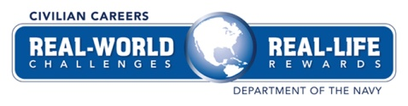



**OCHR**

**FactSheet**

Still Need Assistance?

For additional information about the Executive Leadership Development Program, email the Civilian Workforce Development Division at [CWDD@navy.mil](mailto:CWDD@navy.mil).